**Table S1**

Participant Demographics (N = 152)

|  |  |  |  |  |
| --- | --- | --- | --- | --- |
| Measure | *M* (*SD)* | *n* |  | Percent of Sample |
| Age | 31.5 (10.8) |  |  |  |
| Autism-Spectrum Quotient (AQ) Score | 20.4 (6.7) |  |  |  |
| Sex |  |  |  |  |
| Male |  | 83 |  | 54.6 |
| Female |  | 65 |  | 42.8 |
| Other |  | 2 |  | 1.3 |
| Not reported |  | 2 |  | 1.3 |
| Race/Ethnicity |  |  |  |  |
| White |  | 99 |  | 65.1 |
| Asian |  | 28 |  | 18.4 |
| Black/African American |  | 15 |  | 9.9 |
| Latinx |  | 5 |  | 3.3 |
| Hawaiian/Pacific Islander |  | 1 |  | 0.7 |
| Other |  | 2 |  | 1.3 |
| Not reported |  | 2 |  | 1.3 |
| Nationality |  |  |  |  |
| American |  | 137 |  | 90.1 |
| Other |  | 13 |  | 8.6 |
| Not reported |  | 2 |  | 1.3 |
| Country of Residence |  |  |  |  |
| United States |  | 151 |  | 99.3 |
| Not reported |  | 1 |  | 0.7 |
| Education |  |  |  |  |
| Some high school  High school diploma  Some college/vocational training  College degree  Professional or graduate degree  Not reported |  | 3  14  43  61  29  2 |  | 2.0  9.2  28.3  40.1  1.3  1.3 |
| Color blindness |  | 2 |  | 1.3 |
| Red-green |  | 2 |  | 1.3 |
| Not reported |  | 3 |  | 2.0 |
| Clinical Diagnoses |  |  |  |  |
| ASD |  | 1 |  | 0.7 |
| ADHD |  | 15 |  | 9.9 |
| ASD and ADHD |  | 3 |  | 2.0 |
| Other |  | 17 |  | 11.2 |

**Table S2**

*Results of Logistic Regression*

|  |  |  |  |
| --- | --- | --- | --- |
| **Factor** | ***β* (SE)** | ***Z*** | ***p*** |
| Intercept | 0.25 (0.25) | 1.00 | .319 |
| High Pay | 0.93 (0.42) | 2.23* | .026 |
| Added Instructions | 0.32 (0.37) | 0.85 | .397 |
| High Pay*Added Instructions | -0.29 (0.60) | -0.49 | .627 |

**Figure 1**

*Task Interface and Stimuli*

Set 1:

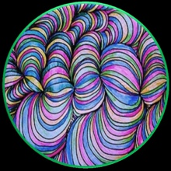

Set 2:

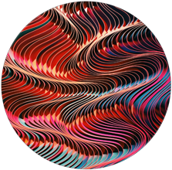

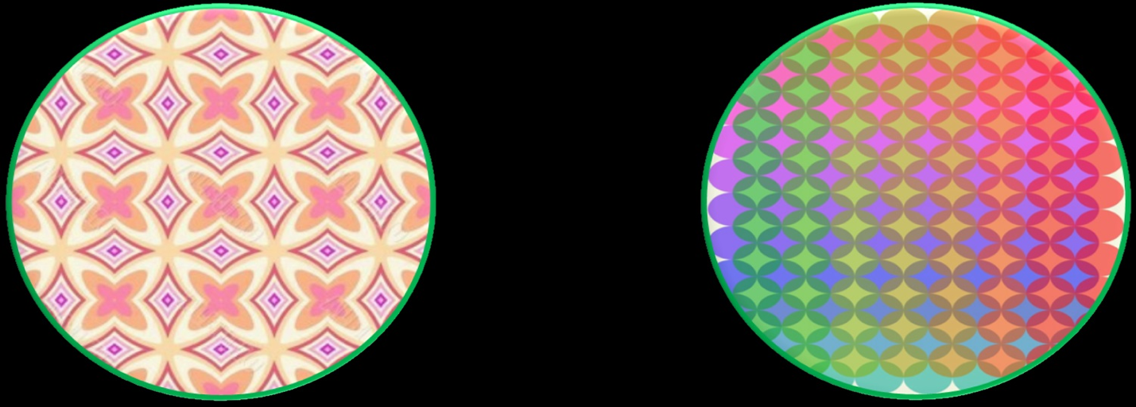

*Note.* This figure shows an example of the task interface (top panel) and stimuli used during each task (bottom panel).